Unofficial Template for American Journal of Physics Manuscripts Prepared Using Microsoft Word
Revised 3/13/2012 18:57:00
Eric L. Michelsena)
Department of Physics, ¹University of California, San Diego,
9500 Gilman Dr. MS-0424 SERF-317, La Jolla, CA, USA 92093
Second Author^{b)}
Some other Institute, Some Department
Some address and mailstop, city, state/province, country postal-code
This unofficial template may be useful in preparing text for American Journal of Physics papers, or not. It is completely unofficial, and not endorsed by American Journal of Physics in any way. I post it in the hope that it will save people some time, but cannot guarantee its use for anything, including journal submissions. Consult the journal web pages for current information, as this template, by itself, is wholly inadequate to prepare a paper. Separately, note that ArXiv requires, if using Word, a Word 2007 *.docx file, which you can easily make from this if you have Word 2007.

Keywords: MS Word, Template
PACS: 95.55.Sh, 93.90.+y, 13.15.+g

- Introduction
This template may be useful in preparing text for American Journal of Physics papers, or not. It is completely unofficial, and not endorsed by American Journal of Physics papers in any way. I have written it according my reading of the journal’s manuscript preparation web pages1, and my observation of a recent paper. Note in particular the publication criteria in ref. 1.
AAPT provides “Web Posting Guidelines for Papers Published in AAPT Journals”.3
Separately, note that ArXiv requires, if using Word, a Word 2007 *.docx file, which you can easily make from this if you have Word 2007.
I am new to this format, and this is my first attempt, so it is likely to have some mistakes. I post it in the hope that it will save people some time, but cannot guarantee its use for anything, including journal submissions. Consult the journal web pages for current information, as this template, by itself, is wholly inadequate to prepare a paper. Please send corrections for this template to me.
Remember that the formatting of your manuscript is largely irrelevant to its final appearance in the journal, since they will completely reformat the text before publication. However, this template helps you see approximately how it will look, and helps with things such as references.
While editing, you should choose “Normal View,” and set _Tools_, _Options_, |View|, Style area width to 0.8” so you can see the paragraph styles on the left. I have only viewed this template on Windows, but it should be largely portable to Mac. Use “Print Layout View” for a better view of how your draft looks on a page.
This template is primarily text formatted with Word paragraph styles that are defined to provide appropriate formatting. Using Word styles is important, because it allows formatting changes to be quickly applied to the entire document by simply modifying the style. Authors can directly use the basic styles defined within this template. However, authors are free to create their own styles, and add them to this template.
Example of writing Latin names appears in the following sentence. Some cultivar C. annuum are not spicy, but all cultivar C. frutescens are spicy.
- How to Use This Template
First, change the header to have your article title on the left, and your target journal on the right
You choose your section titles as you see fit.
In Windows, to use this template, save this file to ‘AmJP.dot’ in a convenient directory. Then, just double click on ‘AmJP.dot’ in any file explorer (such as Windows Explorer). This creates a new Word document from the template. You can then “Save As” the document with a new name.
To attach this template to an existing Word document:
- Open the document in Word.
- Select _Tools_, _Templates_, [Attach].
- Browse to this template file (e.g., AmJP.dot).
Once the document is attached to the template, while editing your document, you can choose a paragraph style from the drop-down box typically located in the upper left corner of Word, below the main menu.
Use SHIFT-F9 to see the coding of fields, instead of their results. Use the [¶] button to see hidden formatting marks, like spaces, tabs, and returns.
- How to Use Styles
It is very important to code the correct Word Style for each paragraph, so that you can change the style once, and every relevant paragraph will instantly be updated. To use styles, authors place the cursor in a paragraph they want to format, click down-arrow in the Style dropdown-box (typically upper left corner of Word), then click the style you want. The following explains how to use each style:
- The manuscript title uses style Title-article. Usually you can just overwrite the title supplied by the template. After applying this style, the template automatically shows style author when the authors press ↵ (Enter button) at the end of title.
- Use style author to create the author’s names. Again, you can usually just overwrite the template.
- Author’s Institution and address are created using style Affiliation.
- Abstract content is created using style Abstract.
- Section and subsection are formatted using Section Title.
- Normal text is formatted using style Normal.
- Figure captions use Figure style. However, the figure graphic uses picture style, which is centered.
- References, Acknowledgement, and Appendix are created using style Section Title.
- References are formatted using style ref.
- Numbered lists use style Numbered.
- Bullet lists use style bullet.
- Acknowledgements use style Section unnumbered.
- Citations
Ref. 2 says, “Within the body of the manuscript, references to endnotes should appear as superscripts placed after any punctuation.”2
I have had problems uploading PDFs with embedded http links to the AmJP web site. I have disabled detection and output of URLs in my PDF generator.
- Equations
Am J P2 refers to author guidelines from AIP, which says equations should be encoded in MathType,4 and look like this:
(1)
Ref. 2 says, “Each equation should appear on a separate line with proper punctuation placed before and after it.”
You number equations and reference them just like references and citations: equation (1) is an integral. You can put short, unnumbered equations inline: .
- Figures
If your manuscript contains figures, they are typically placed in one column. A large figure might span two columns.
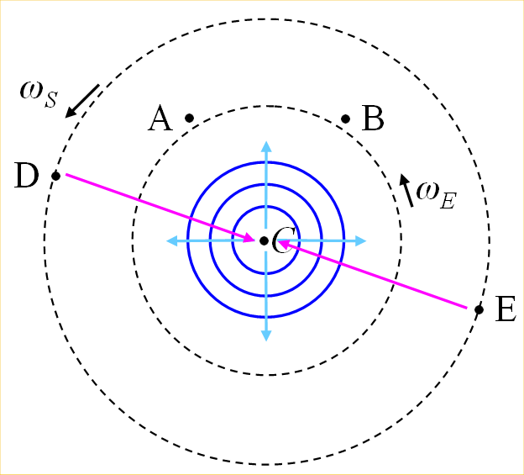
FIG. 1. (Color online) A central clock, orbited by one or more clocks. Figure captions use Figure style. The figure image itself uses picture style.
Since one column is 3.25 inches wide, a 600 dpi figure should be 1950 pixels wide. A 300 dpi figure would be 975 pixels wide. I suggest your separate figure files should have obvious names, such as “fig1.eps”, “fig2.eps”, etc.
I suggest you do not submit with embedded powerpoint slides, etc. You must include any *.png and similar files in the Word manuscript.
- Conclusions
With this unofficial template, we hope authors can prepare their manuscript easily. This template is not endorsed by any journal in any way, and may contain errors. For some formats, such as Table and hierarchical lists, authors must create their own format. Please submit comments and corrections to the author, at the email address given.
acknowledgements
- Acknowledging the Help of Anonymous Reviewers
Ref. 2 notes, “While it is not appropriate to acknowledge the assistance of the editors, it is appropriate to acknowledge specific help and advice from our generous, conscientious, and anonymous reviewers. Examples of specific help are suggestions for references, pointing out significant errors, and suggesting better ways of doing calculations or experiments.”
Put references below the acknowledgements (and appendixes, if any). Note that the reference numbers use a {seq refer} field inside a {bookmark } field. You cite the reference in the text with a {ref bookmark-name } field. For references, copy and paste an existing one, then edit its text, add a bookmark (typically with the author as the bookmark name), select the reference number, and press F9 to update the number according to its order in the list. You can also select the whole list, and update all of them at once.
Appendix
“Endnote references to articles in periodicals should have the following form with the title of the article and the final (as well as the initial) page numbers. Use of the issue number is encouraged but not required unless the reference would otherwise be ambiguous... .”²
Endnotes, including the author’s email address, use sequence ‘endnote’.
- First Subsection
Subsections are numbered.
- First Sub-subsection
Sub-subsections are lettered.
- Second Subsection
Blah.

^{a)}Electronic mail: emichels@physics.ucsd.edu
^{b)}Electronic mail: author2@some.where.edu
¹http://ajp.dickinson.edu/Contributors/contGenInfo.html, retrieved 3/12/2012.
²http://ajp.dickinson.edu/Contributors/manFormat.html, retrieved 3/12/2012.
³http://ajp.aapt.org/authors/web_posting_guides, retrieved 3/12/2012.
⁴http://www.aip.org/pubservs/compuscript.html, retrieved 3/12/2012.
[5] P. Adamson et al. (MINOS collaboration), Phys. Rev. D 76, 072005 (2007).
[6] K. Hirata et al. (KAMIOKANDE-II Collaboration), Phys. Rev. Lett. 58, 1490 (1987).
[7] T. Kobayashi, H. Yoneyama, and H. Tamura, J. Electroanal. Chem. 177, 281 (1984).
[8] Fitrilawati, R. E. Siregar, dan M. O. Tjia, Jurnal Matematika dan Sains 2, 16 (1997).
[9] Sukrasno, dan S. Kusmardiyani, Jurnal Matematika dan Sains 2, 28 (1997).

